MATH6119 – Analytical Consultancy Skills

Assignment Report

GROUP 5:
37569597
36938912
37652435
36842427
37218557
36945811

Part 1: Setting up the working environment
Introduction
In multi-module algorithmic projects, the primary risk is system integration failure due to data schema mismatches, hardcoded file paths, and version control conflicts. To ensure the successful optimization of the PCB assembly process, a robust software engineering framework is required to guarantee seamless data handover between developers. This part is designed to establish a shared working environment, ensuring that all members can access all resources in real time.
1. Architectural Design and Workflow
We have established a file directory structure for the entire project; please refer to the ‘README’ file for further details. This structure provides a clear overview of the project’s framework. Based on this framework, we have created a repository on GitHub, which all members can use to download or upload the required files to the appropriate locations. For example:
- data/ is strictly partitioned into raw/ (source), intermediate/ (data contracts), and output/ (machine logs).

- src/ and tests/ isolate business logic from testing environments.
Furthermore, for collaborative development, a strict Git branching strategy was enforced. The main repository is locked as the "single source of truth," and all algorithmic development is isolated in separate feature branches to prevent code conflicts.
2. CSV file and column name conventions and coding standards
To ensure interoperability across modules, strict data contracts were established:
- Schema: Final output logs must adhere to a rigid 6-column format (e.g., step_id, action, x_coord).

- Pathing: Hardcoded absolute paths are banned. All scripts utilize dynamic relative pathing for cross-platform compatibility.

- Environment: Python dependencies are synchronized team-wide via a requirements.txt file.

3. Automated Quality Assurance Tool
To guarantee solution integrity, a custom Continuous Integration (CI) Python script (validator.py) was developed. Before any code is merged into the main branch, this automated gatekeeper programmatically verifies:

- File & Schema Integrity: Confirms the existence of all required logs and validates column headers.

- Constraint Verification: Parses the outputs to mathematically prove that exactly 102 valid PLACE actions were executed across the three machines, with zero missed or duplicated components.

By shifting quality control to an automated script, this methodology eliminates human inspection errors and ensures the final machine protocols are robust and ready for deployment.

Part 2: Data preparation
2. Data Preparation and Preprocessing
Before the optimisation process could begin, the original PCB layout information needed to be converted into a standardised format that could be shared across all modules of the project. The purpose of this stage was to prepare clean CSV datasets for later attachment allocation, task assignment and path planning.

2.1 Attachment and Component Mapping
The first preprocessing task was to organise the relationship between attachment heads and the components they can support.
Head Type | Supported Components
α1 | C, F, G
α3 | B, G, H
α5 | E, I
α9 | D
Table 1. Example of attachment-component mapping

2.2 Feeder Coordinate Processing
The feeder locations were converted into a standard coordinate dataset. All feeders are located on the bottom row where y = 0.
Component | X Coordinate | Y Coordinate
A | 1 | 0
B | 2 | 0
C | 3 | 0
D | 4 | 0
E | 5 | 0
Table 2. Example of feeder coordinates

2.3 PCB Position Dataset
The PCB layout was converted into a structured coordinate dataset. Feeder bins are located at y = 0, while PCB component positions begin from y = 1.
Component | X Coordinate | Y Coordinate
E | 1 | 1
F | 2 | 1
D | 3 | 1
H | 4 | 2
G | 10 | 12

Table 3. Example of PCB component positions

2.4 Component Distribution
Component | Count
A | 5
B | 8
C | 11
D | 11
E | 24
F | 10
G | 11
H | 10
I | 7
J | 5
Figure 1. Distribution of PCB component types
Component E appears more frequently than the other component types, which later became important during workload balancing.

2.5 Summary
Overall, the preprocessing stage standardised all PCB-related information into consistent CSV datasets for later optimisation stages.

Part 3: Generation of the attachment allocation plan
3.1. Aims
The task of this part is to complete the design of the accessory allocation scheme of the chip machine, that is, assign 9 accessories (α1 to α9) to the 3 head slots of 3 machines M1, M2 and M3, and output this is a standardised CSV file for subsequent task allocation and path planning module reading.
The module does not directly handle the position of 102 component points on the PCB, nor is it responsible for path optimisation. It only designs various distribution schemes with different optimisation concepts under the premise of meeting the constraints of attachments to provide a basis for subsequent comparison and selection.
3.2. Background
There are a total of 9 attachments in this question:
- α1：C/F/G
- α2：C/F/G
- α3：B/G/H
- α4：C/H
- α5：E/I
- α6：A/E
- α7：E/J
- α8：B/C/I
- α9：D
Among them, the most important hard constraint is that α9 only supports component D, so whichever machine is configured with α9, which machine must have the ability to process all D components. This means that the allocation of α9 will directly affect the processing of special components in the entire production line.
In addition, according to the background of the topic, E is an ultra-high frequency component, so the distribution of α5, α6 and α7 related to E will significantly affect the workload distribution of each machine. And because the pick order is fixed as head1 -> head2 -> head3, the order of attachment will also affect the continuity of feeder movement.
3.3. Design Concept
The design principle of this module is:

1. Satisfy the relationship between attachment and component capability mapping;
2. Ensure that all 9 attachments are used at once;
3. Each machine is exactly assigned 3 heads;
4. Design a variety of candidates for different optimisation goals;
5. Output CSV files in a unified format to facilitate the direct call of subsequent modules.
3.4. Scheme Design and Analysis
3.4.1 Baseline
The core idea of this scheme is to equally disperse the pressure of high-frequency components. Since E is an ultra-high frequency element, and α5, α6 and α7 all have the ability to process E, these three attachments can be distributed equally to three machines to avoid a machine monopolising the high-frequency E task.
The specific allocation is as follows:
M1: α6(A/E), α8(B/C/I), α9(D)
M2: α1(C/F/G), α5(E/I), α3(B/G/H)
M3: α2(C/F/G), α4(C/H), α7(E/J)
Among them, M1 is more inclined to low-frequency and special component processing, especially D components; M2 and M3 jointly undertake medium and high-frequency components. The advantages of this scheme are intuitive structure and strong feasibility, which is suitable as a benchmark scheme for all subsequent experiments. At the same time, try to follow the idea of increasing the feeder from left to right in the head order to reduce the invalid jump in the pick stage.
3.4.2 Balanced Load
The goal of this scheme is not simply to switch machine allocations, but to ensure that all three machines have relatively similar attachment capabilities, preventing any one machine from becoming a bottleneck due to handling too many specific components.
The specific allocation is as follows:
M1: α1 (C/F/G), α4 (C/H), α7 (E/J)
M2: α2 (C/F/G), α5 (E/I), α8 (B/C/I)
M3: α3 (B/G/H), α6 (A/E), α9 (D)
This scheme is characterized by each machine simultaneously covering different levels of component capabilities, rather than concentrating certain types of attachments on a single machine. For example, all three machines can handle some high-frequency components while retaining the ability to handle different types of low- and mid-frequency components. This allows for a more balanced attachment capability across the three machines, thereby reducing the risk of excessive workload on a single machine.
3.4.3 Feeder travel
The scheme focusses on optimising feeder movement, rather than simply pursuing workload balance. Since the feeder is roughly arranged in A -> J on the x axis, and the pick order of the machine is fixed, if the attachment order corresponding to the head is more consistent with the direction of the feeder coordinates, the shift of the pick stage The dynamic path will be more continuous.
The specific allocation is as follows:
M1: α6(A/E), α8(B/C/I), α9(D)
M2: α3(B/G/H), α1(C/F/G), α5(E/I)
M3: α4(C/H), α2(C/F/G), α7(E/J)
The most important thing in this scheme is not whether the division of labour between machines is the most uniform, but the arrangement of the internal head order of each machine. For example, the attachment order of M2 has been adjusted to make its feeder movement closer to continuous right shift instead of jumping back and forth left and right. This scheme is suitable for combining with the follow-up path planning module to analyse the changes in the travel distance of the feeder area.
3.4.4 Type Clustering
The scheme adopts the attachment type clustering idea to centralise similar types of attachments into the same machine, so that each machine is more biased to handle components of a certain specification.
The specific allocation is as follows:
M1: α1(C/F/G), α2(C/F/G), α3(B/G/H)
M2: α4(C/H), α5(E/I), α6(A/E)
M3: α7(E/J), α8(B/C/I), α9(D)

The advantage of this scheme is that the attachment type inside the machine is more centralised and the processing logic is clearer. The same type of feeder will be accessed continuously, so it can reduce the significant switching between completely different feeder areas. It is more suitable for a production environment with more centralised component categories.
3.4.5 Throughput Optimized
The scheme refers to the typical structure of the SMT production line and simulates the organisation of "high-speed front section, middle transition, and complex rear section". The front machine tries to continuously process high-frequency small components, the middle machine handles general complexity tasks, and the last machine is responsible for special components and complex components.
The specific allocation is as follows:
M1: α1(C/F/G), α2(C/F/G), α6(A/E)
M2: α3(B/G/H), α4(C/H), α5(E/I)
M3: α7(E/J), α8(B/C/I), α9(D)
The goal of this scheme is to improve the overall production throughput so that the front-stage machine can continue to work efficiently, while tasks with higher complexity and possibly slower processing speed are concentrated in the rear-stage machine. Compared with equal distribution, it adjusts the rhythm organisation of the line body more strongly.
3.4.6 Redundancy
The starting point of the plan is the robustness of the system. In order to avoid a machine completely monopolising the ability of key components, commonly used attachments are distributed to different machines, so as to improve redundancy.
The specific allocation is as follows:
M1: α1(C/F/G), α6(A/E), α8(B/C/I)
M2: α2(C/F/G), α4(C/H), α9(D)
M3: α3(B/G/H), α5(E/I), α7(E/J)
This scheme is not necessarily the most efficient under normal circumstances, but it can make attachment capability more decentralised and reduce the risk of "biased machines". If a machine is overloaded or abnormal in actual production, other machines can still undertake some key component tasks.

3.5. Program Implementation
This section describes the Python script `assignment_generator.py`, which reads the order of nine attachments from `mapping.csv` and automatically generates multiple assignment files according to a preset machine layout. The program primarily performs the following functions:
1. Reads the `head_type` from `mapping.csv`;
2. Defines the machine layout for different assignment schemes;
3. Checks for duplicate attachments;
4. Checks if all nine attachments are used;
5. Outputs the results as standardized CSV files.
Output files include:
assignment.csv, assignment_baseline.csv, assignment_balanced.csv, assignment_feeder_friendly.csv, assignment_size_clustered.csv, assignment_throughput.csv, assignment_redundant.csv.
The assignment.csv file is equivalent to the baseline scheme by default to ensure compatibility with the validation script.
Part 4: Code implementation of the allocation method

4.1 Aims
The task of this part is to generate an effective picking and placement work plan for the three assembly machines after determining the allocation of accessories. The module reads the prepared input CSV files, including accessory component mapping, feeder box coordinates, PCB component location and machine accessory allocation.
The main goal is to assign all 102 PCB components to a valid machine head and output three standardised machine operation log files. Each output file represents the work plan of a machine and contains the required PICK and PLACE operations. Then, the generated file is used as the final machine instruction, which can also be checked through the verification script.
This module does not redesign the attachment allocation scheme. Instead, it uses the selected attachment arrangement as input and focusses on converting it into a feasible machine-level operation log.

4.2 Background
In this question, each machine has three attachment heads. Each head is equipped with an attachment, and each attachment can only handle specific component types. Therefore, before assigning the PCB component to the machine, it is necessary to check whether at least one head on the machine can handle the component.
The accessory capability mapping used in this module is shown in Figure 1. A hard feasibility limitation is that components can only be assigned to their accessories to support the type of head of component. For example, component D can only be processed by α9, so any D component must be assigned to a machine containing α9.
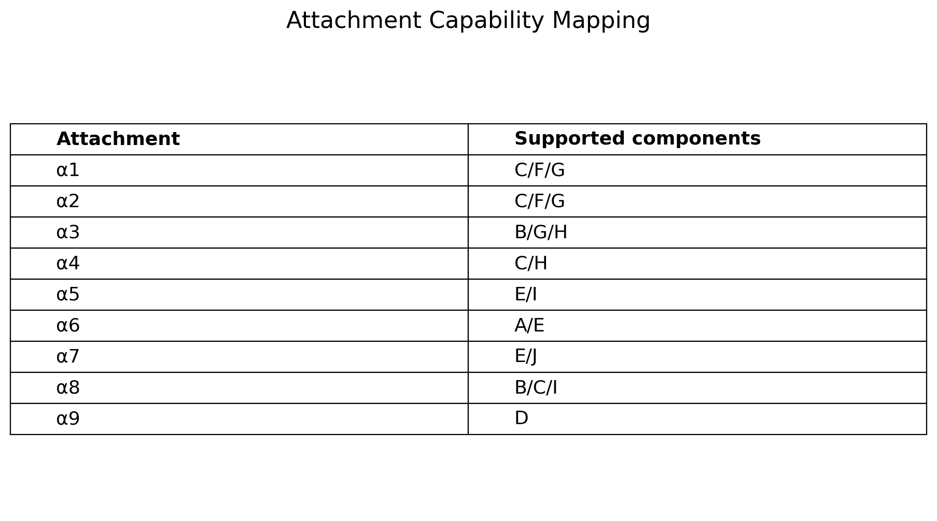
Figure 1. Attachment capability mapping.
In addition, the task should avoid overloading a single machine. Because the speed of the conveyor belt is affected by the slowest machine, a more balanced workload is preferable. Therefore, the module uses a simple distance-based workload estimate to distribute components more evenly on three machines.

4.3 Design Concept
The design principle of this module is to ensure that each PCB component is assigned to the legitimate machine head and that all 102 PCB components are included in the final output. This module avoids assigning components to incompatible attachments and uses load balancing methods to reduce the risk of a machine becoming a bottleneck. At the same time, it will generate standardised CSV output files for three machines and ensure that the whole process can be reproduced through Python scripts.
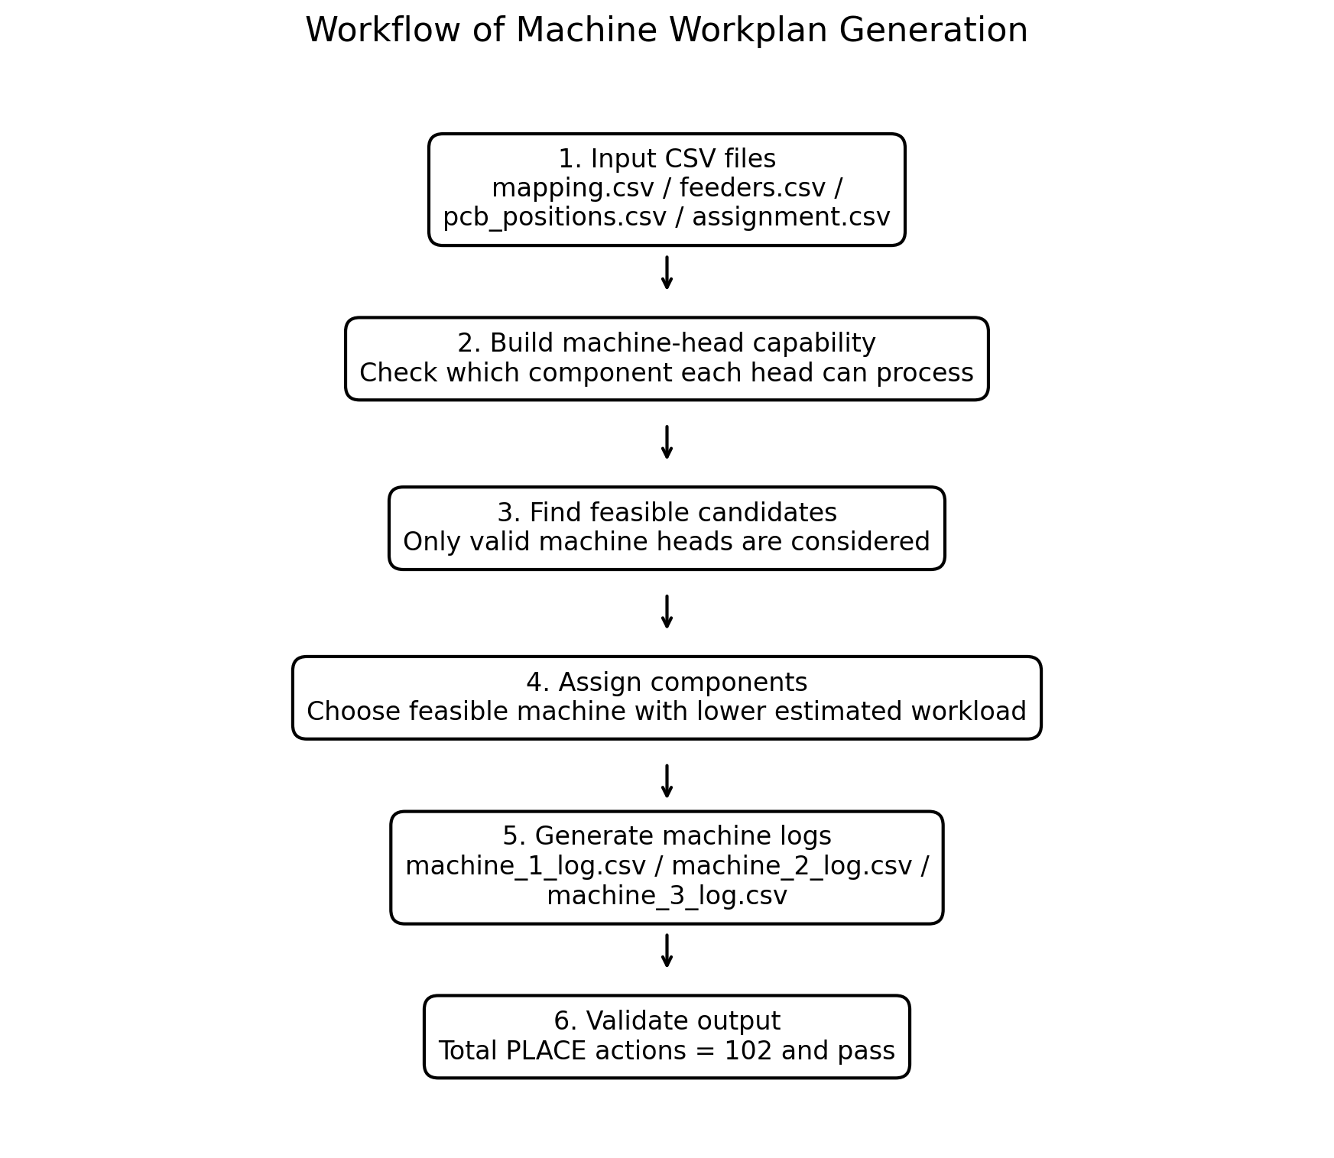
Figure 2. Workflow of machine workplan generation.

4.4 Task Allocation Method
The algorithm first reads the attachment allocation file and the attachment component mapping file. From these two files, it constructs the capability set of each machine head. For example, if machine 1 has α6, α8 and α9, then the machine can handle the components supported by these accessories, including A, E, B, C, I and D.
For each component position on the PCB, the algorithm recognises all valid candidate heads. The candidate is only valid when the corresponding attachment supports the component type. THIS ENSURES THAT EACH GENERATED PICK AND PLACE OPERATION IS MECHANICALLY FEASIBLE.
If a component can only be processed by one machine head, it will be assigned directly to that head. If multiple machine heads can handle the same components, the algorithm will select the candidate whose machine currently has the lowest estimated workload.
The estimated workload is calculated using a simple distance approximation:
origin → feeder bin → PCB placement location → origin
This is not the final exact travel distance, but it provides a practical estimate to balance the workload during the assignment of tasks. The purpose of this heuristic is to prevent allocation based solely on the number of components, because the two components may have very different travel distances, depending on their feeders and PCB positions.

4.5 Workplan Generation
After all PCB components have been assigned to valid machine heads, the algorithm generates three machine operation logs:
machine_1_log.csv
machine_2_log.csv
machine_3_log.csv
Each file follows the required output format with the columns: step_id, action, component, head_id, x_coord, and y_coord. For each assigned component, the program records a PICK action at the feeder bin coordinate and a PLACE action at the corresponding PCB coordinate. The head_id column records which machine head is responsible for the component.
The generated workplans therefore provide a clear sequence of operations for each machine. They also allow the validator to check whether the correct number of components has been placed.

4.6 Result and Validation
The summary of the final task assignment results is shown in Figure 3. Since each component will generate a PICK operation and a PLACE operation, the total number of output lines is twice the number of assigned components.
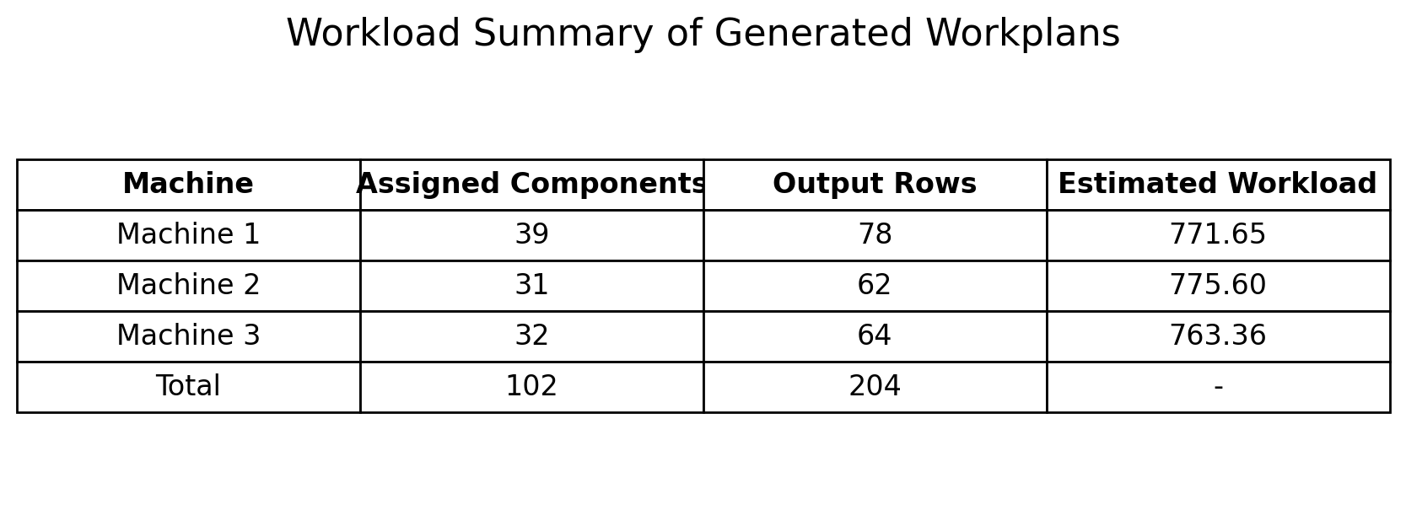
Figure 3. Workload summary of generated workplans.
Although Machine 1 allocates more components than the other two machines, the estimated workload of the three machines is relatively close. This shows that the allocation method is not simply balanced by the number of components, but based on the estimated moving distance to balance the workload of the three machines.
The output file has been checked with validation script. The validator confirms that there are a total of 102 PLACE operations in the three machine logs, which means that all the PCB components required to be placed have been included in the generated workplans.
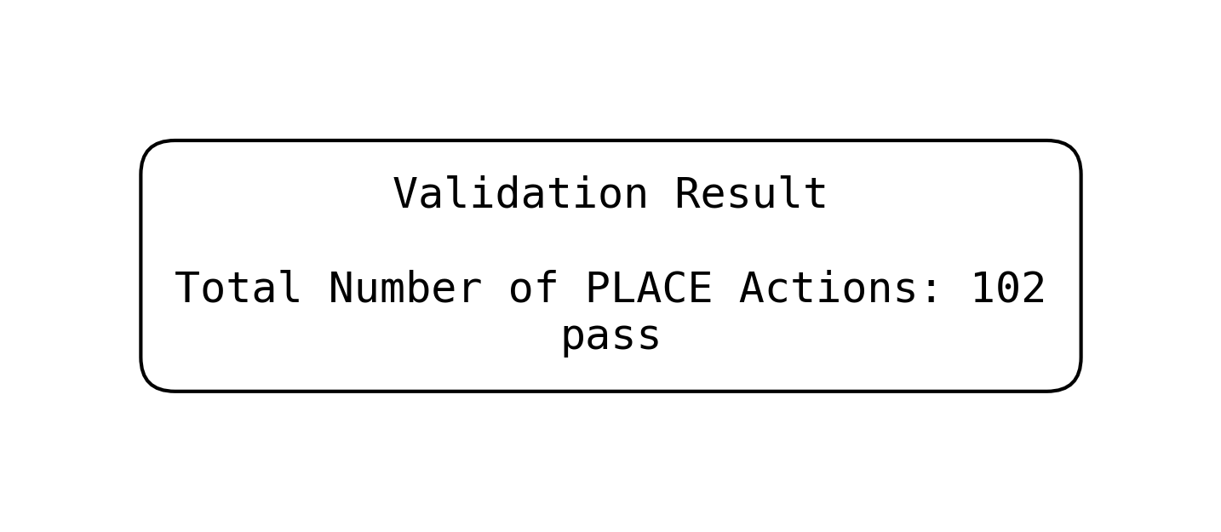
Figure 4. Validation result of generated machine workplans.

4.7 Program Implementation
This module is implemented through the Python script algorithm.py. The script reads the prepared CSV input files, including mapping.csv, feeders.csv, pcb_positions.csv and assignment.csv. Then, the program will build a collection of processing power for each machine head, assign each PCB component to a legitimate machine head, and generate three standardised machine operation log files. This implementation only uses the Python standard library, so there is no need to install additional third-party packages.

4.8 Limitations and Possible Improvements
The current method provides a feasible baseline solution. It can ensure that each component is assigned to a compatible machine head and that all required PCB components are included in the final output. However, the current workload estimate is based on a simplified distance approximation, rather than a complete simulation of all pick-and-place phases. Further improvements can be done in the future, such as combining up to three components into the same phase and optimising the placement order to further reduce the total moving distance.

Part 5: Testing and Assessment
The last phase of the project was to determine the validity, completeness and appropriateness of the proposed attachment allocation and machine workplans for submission. All necessary CSV files were first tested for structure. The results verified that the input files, assignment files and output machine logs were in the proper format and column names. This was significant because the automated assessment system needs consistent CSV structures for the attachment mapping, feeder coordinates, PCB positions, assignment plan and machine operation logs.
The six strategies for assignments were then validated. The assignment validation test was successfully completed for all 6 strategies. Each strategy had exactly nine rows, and each row was used exactly once, each head was assigned to exactly three machines, and each machine had exactly three heads. This validated all proposed P3 strategies and met the core attachment allocation rule.
The strategy assessment was based on the six assignment plans, with estimated workload balance and feeder-pick travel. The best performing strategy was assignment_balanced.csv, which had the lowest estimated score of 46.17. This strategy resulted in machine workloads of 82 for M1, 89 for M2, and 69 for M3, which leads to a workload gap of 20. The pick travel was slightly lower for the feeder friendly strategy, but the workload gap was higher. So, the balanced strategy was best overall compromise between workload distribution and feeder movement. This is consistent with the P3 logic of a balanced allocation, which ensures that each machine has a combination of attachment capabilities, hence reducing bottlenecks.
The final machine logs were also tested, machine_1_log.csv had 39 PICK actions and 39 PLACE actions, machine_2_log.csv had 31 PICK actions and 31 PLACE actions, and machine_3_log.csv had 32 PICK actions and 32 PLACE actions. The three logs had a total of 102 PICK actions and 102 PLACE actions. The number of PCB components placed was also expected to be 102, and that is exactly what was done. All actions were found to be PICK or PLACE, so no invalid action types were detected.
In general, the project outputs are valid and complete as confirmed by the Part 5 assessment. All CSV files are correctly formatted, all 6 attachment strategies are valid, the balanced assignment is the strongest attachment strategy, based on the heuristic assessment, and all 102 PCB components are successfully placed in the final machine log file. Thus, the results can be submitted for final validation.

Conclusion

By establishing a standardised collaborative environment based on a code repository and automated verification scripts, our team effectively avoided code conflicts and data errors, and successfully optimised the PCB assembly process. Our methodology employs a highly reproducible modular design. First, allocation scripts are used to generate six distinct component allocation strategies, followed by a distance-based load-balancing heuristic algorithm for final task allocation. You can fully replicate our workflow simply by cloning our code repository, placing the raw data in the designated directory, and running the allocation and algorithm scripts in sequence. Final evaluation results show that the system successfully generated fully compliant pick-and-place instructions for all 102 components. The ‘Load Balancing’ strategy performed best in testing, achieving efficient collaboration among three machines (with workloads of 82, 89 and 69 respectively) at the lowest estimated cost (46.17). Verified by the automated programme, the system achieved zero omissions and zero errors, demonstrating the robustness and reliability of this method.

